e-GOS Amendments Guide

The e-GOS system provides a way for agencies to issue amendments to orders. Follow these steps to easily add or delete documents, distribute an extension notice, or update a point of contact.
Note: Each of these actions must be processed as a separate amendment.

- In your web browser, go to https://cio.egos.nih.gov/#login and enter your username and password.

- Select the order from your Orders list.

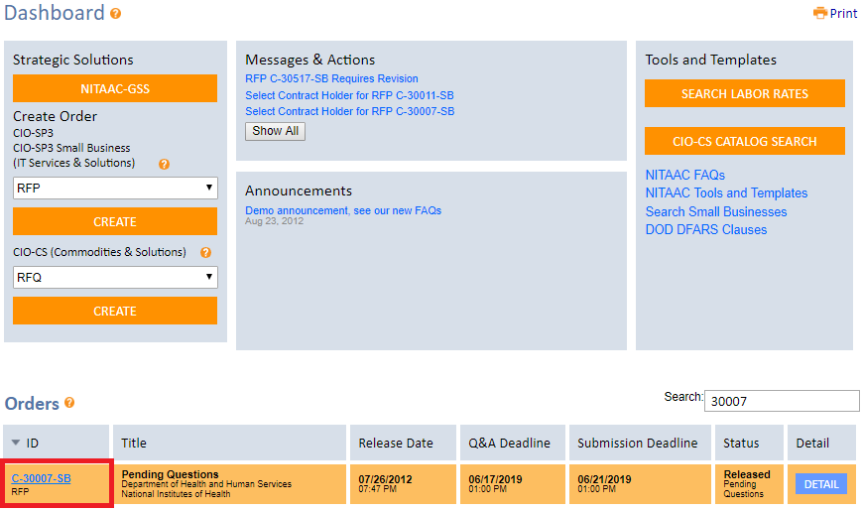

- Once you have selected the order, you will land on an order summary page. From here, click the “Compete” tab.

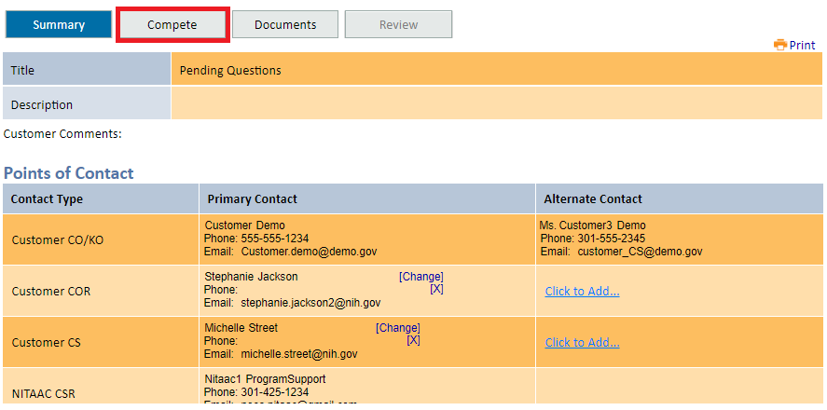

- Select the Amendments subtab and you will see buttons to add or delete documents, give an extension notice, or update a point of contact.

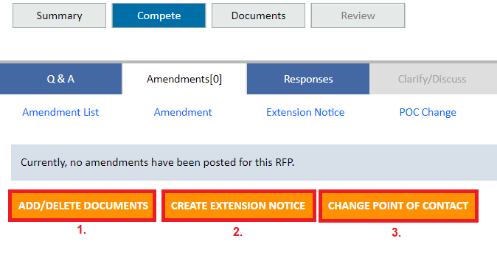

- To add or delete documents, begin by clicking the “Add/Delete Documents” button. Type the reason for the amendment in the text field, then upload a new document or delete an existing document from the list. Once all changes are completed, click the “Release” button to release the amendment to contract holders.

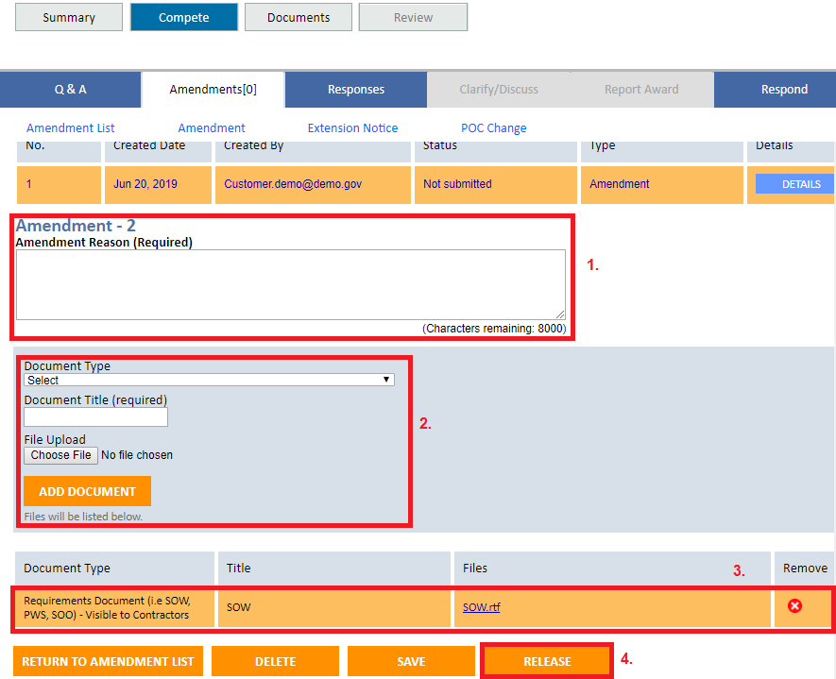

- To issue an extension notice, begin by clicking the “Create Extension Notice” button.

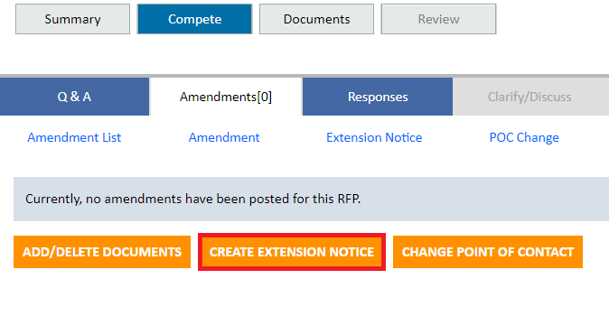
- Next, type the reason for the amendment in the text field, then update the Q&A and/or proposal submission deadline date and time fields. Once the changes are complete click the “Release” button to release the amendment to contract holders.

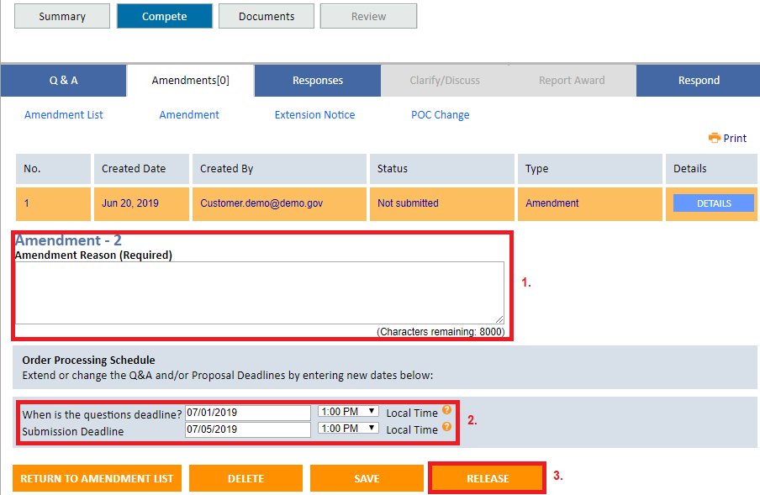

- To update the point of contact, begin by clicking the “Change Point of Contact” button.

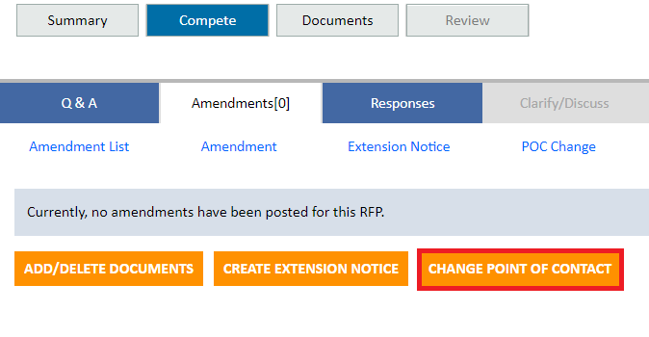

- Next, type the reason for the amendment in the text field, then click the “Change” button next to the point of contact you wish to update. Enter the information for the new point of contact and then click the “Release” button to release the amendment to contract holders.

